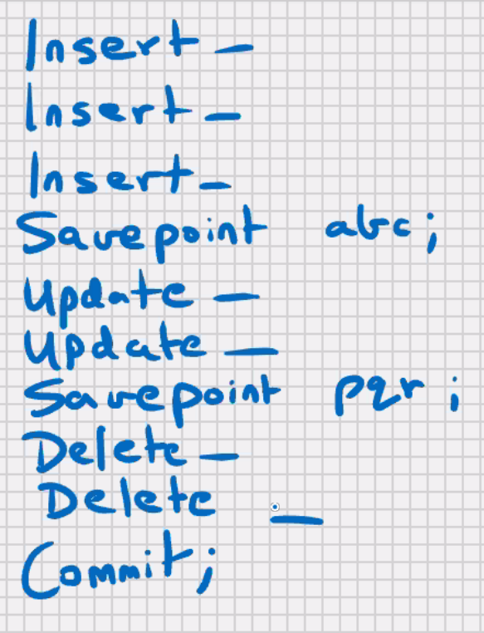

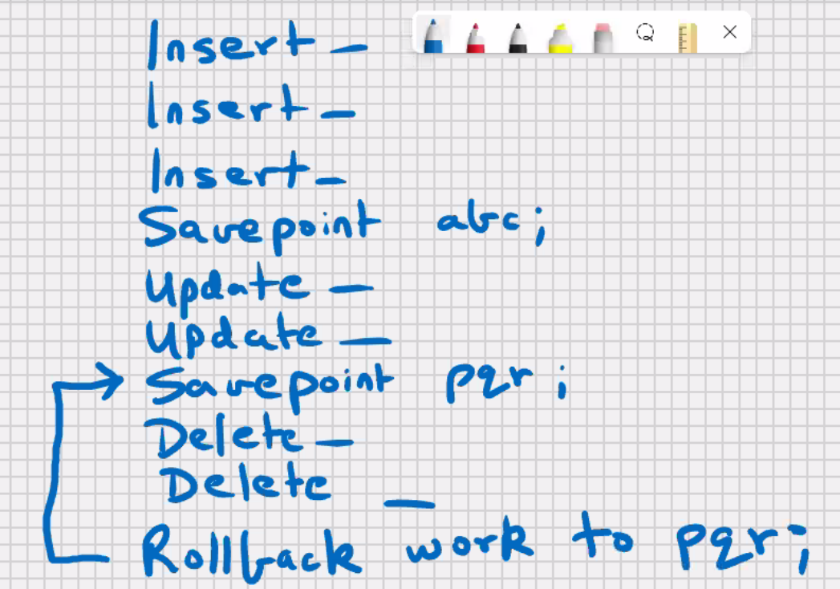

* Savepoint is a point within your work
* Savepoint is a subunit of transaction
* Savepoint is similar to a bookmark
* Within a transaction you can issue the savepoint at regular intervals
* You can rollback to a savepoint

Rollback work to pqr;

Or

Rollback to pqr;

* Work is ANSI SQL
* Work is optional in MySQL and Oracle
* You cannot commit to a savepoint
* Commit will save all the DML changes since the last committed state

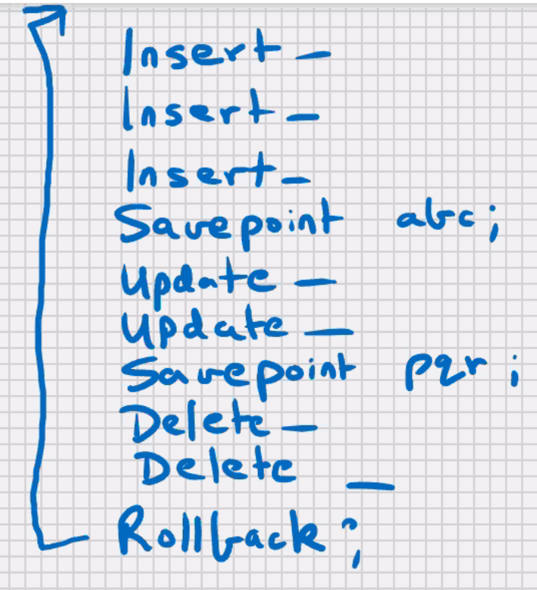

* You can only rollback sequentially
* When you rollback or commit, the intermediate savepoints are cleared. If you want to use them again then you will have to reissue them in some new Work

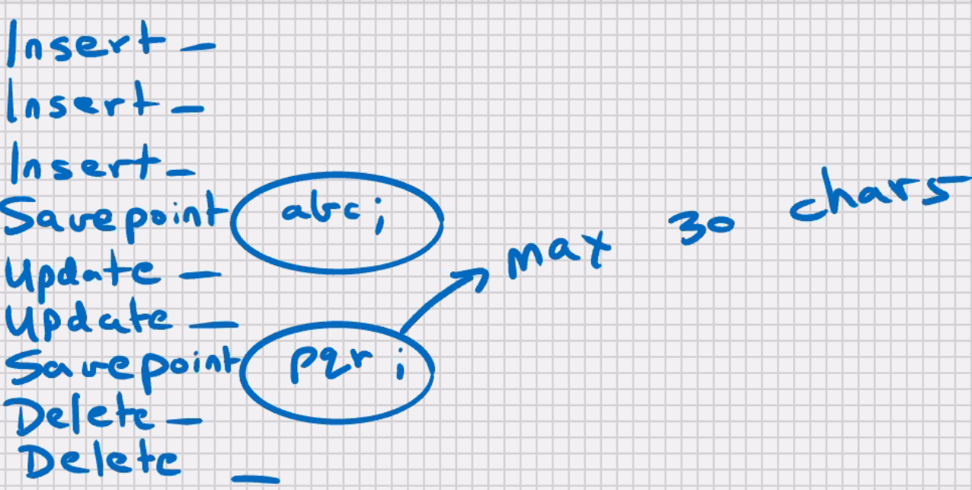

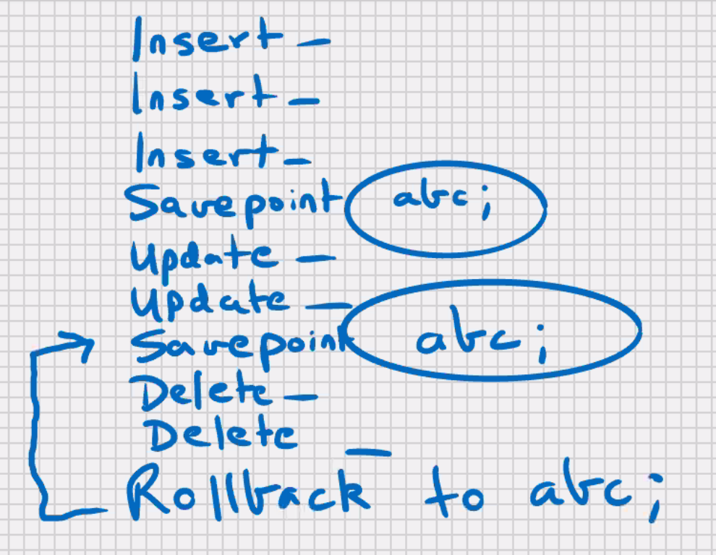

* Within a transaction you can have 2 savepoints with **same name**; the new savepoint **overwrites** the previous one;

The older savepoint no longer exists.

* Savepoints will be used in small and large transactions.
* To try out commit, rollback, and savepoint in my sql workbench
* Click on edit (menu at top)->auto commit transactions-> uncheck it

**Read and write consistency**

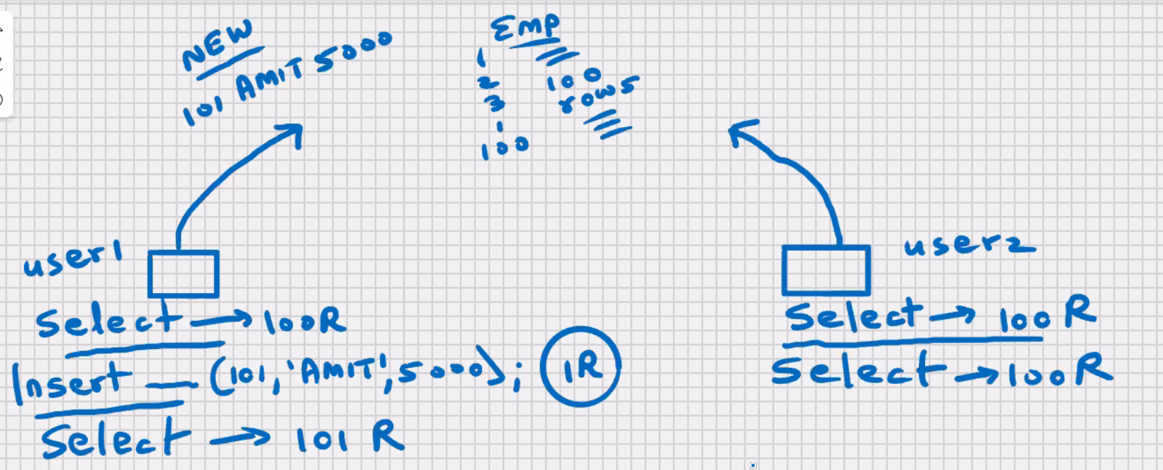

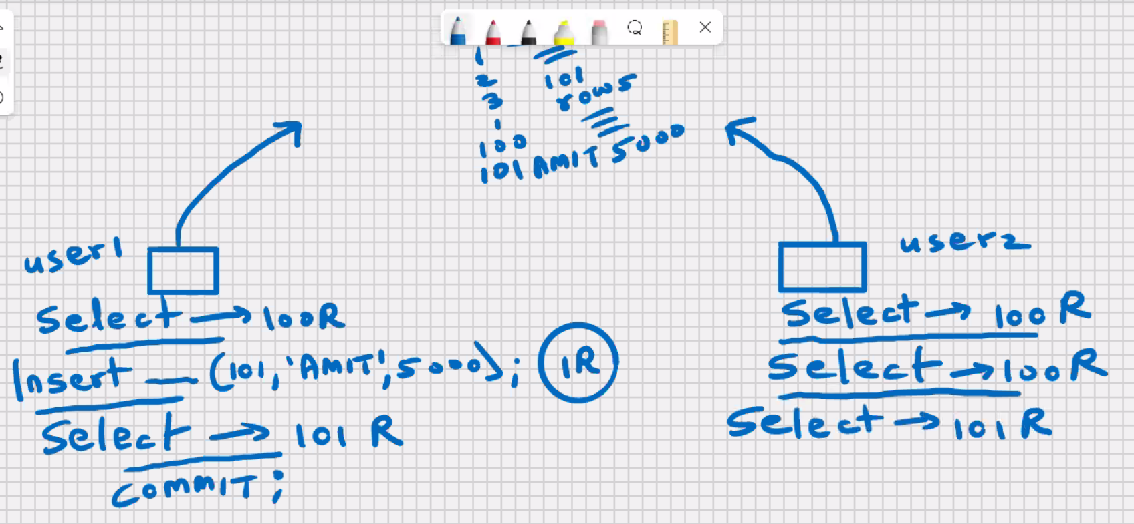

When you select from table you can view only the committed data of all users plus changes made by you

Multiuser environment

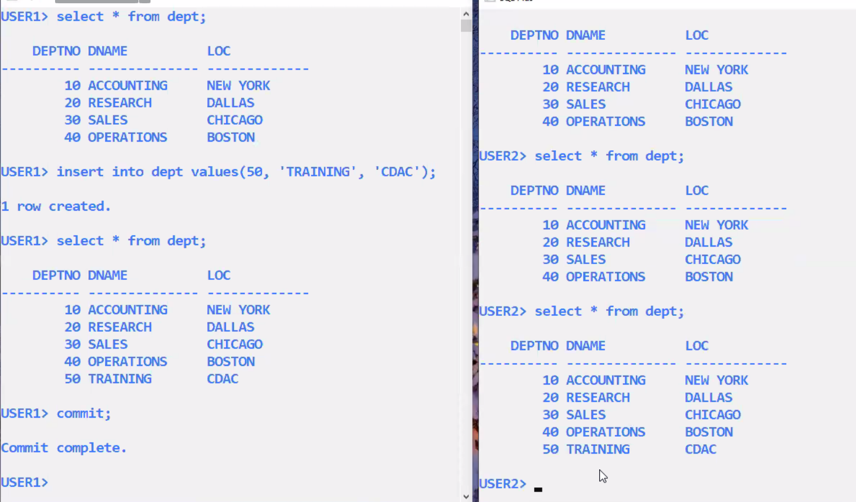

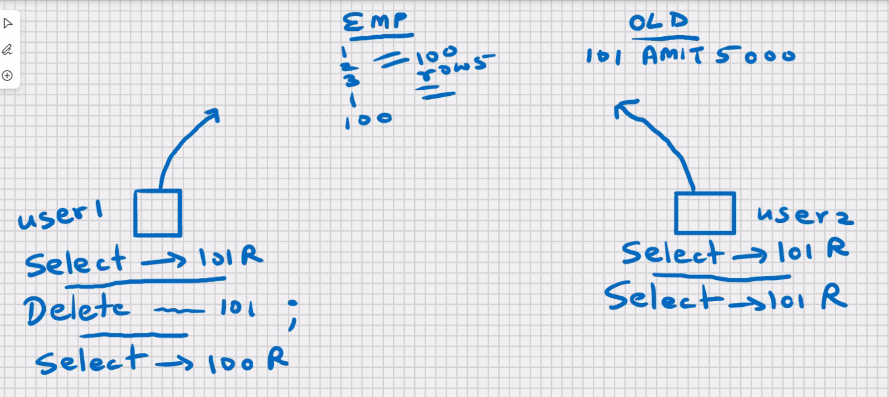

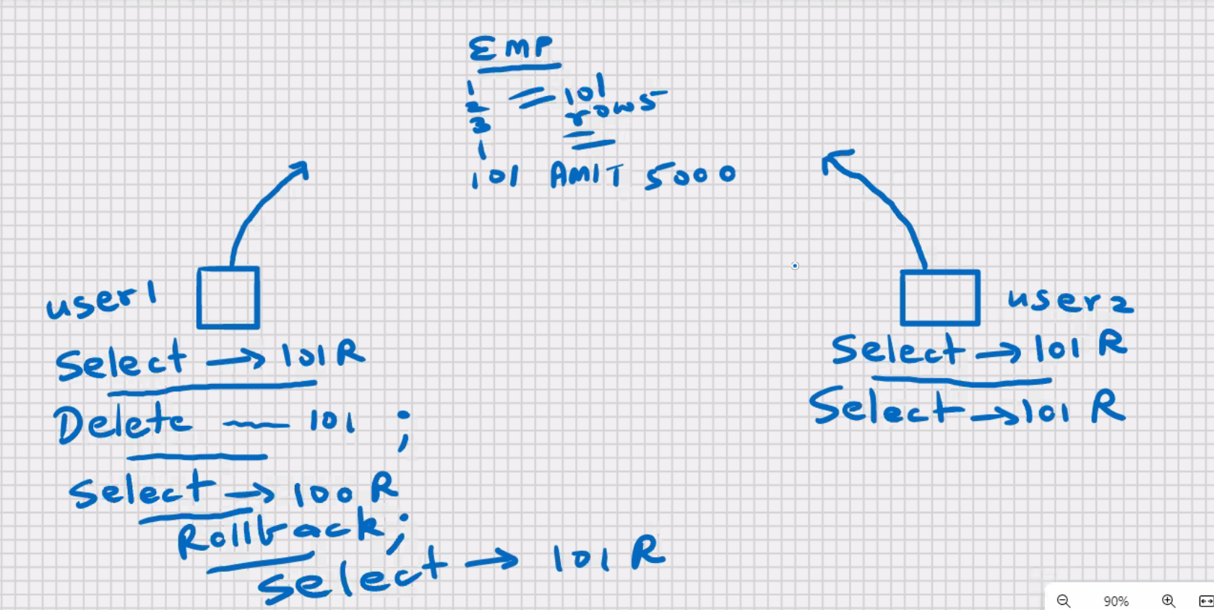

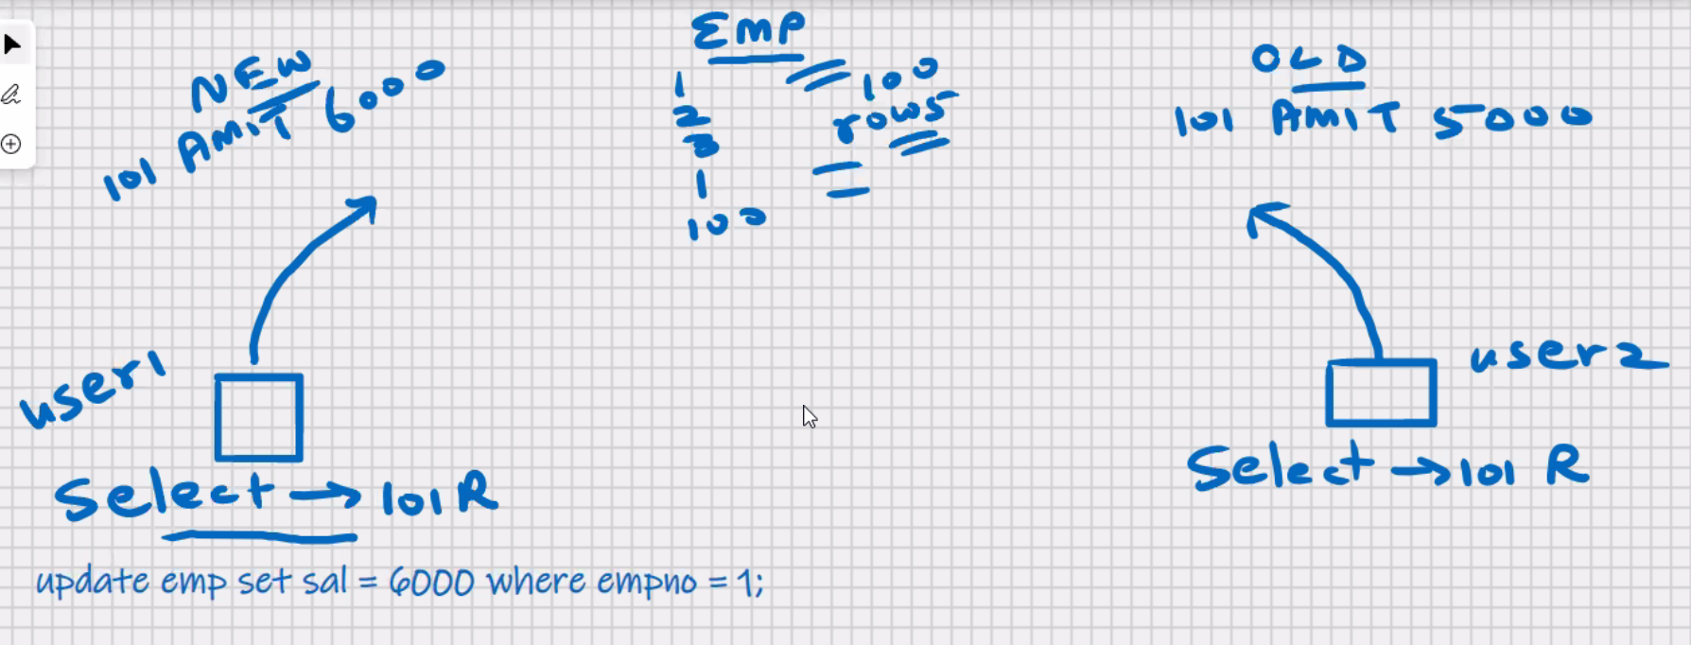

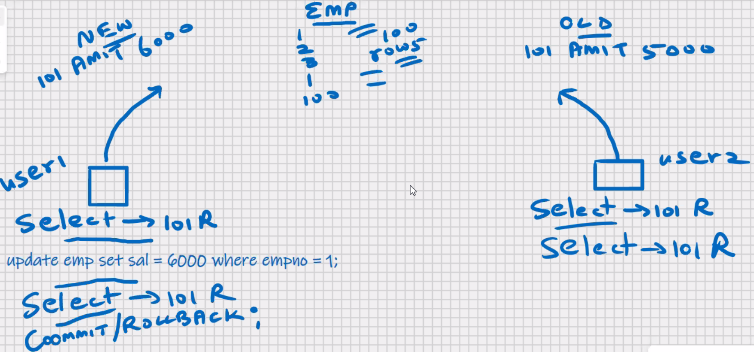

* When you update or delete a row, that row is automatically locked for users
* When you update or delete a row, that row becomes read_only for other users
* Row locking is automatic in mysql and oracle
* Other users can select from that table; they will view the old data before your changes
* Other users can insert into that table
* Other users can update or delete “other” rows from that table
* No other user can update or delete your locked row, till you have issued a rollback or commit
* Locks are automatically released when you rollback or commit

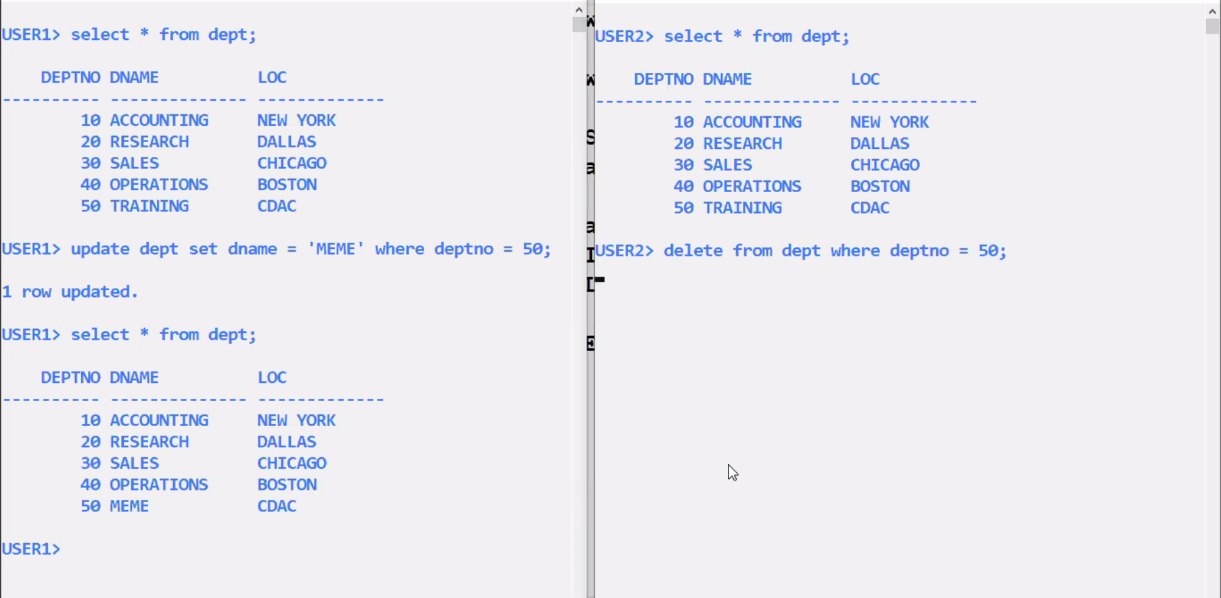

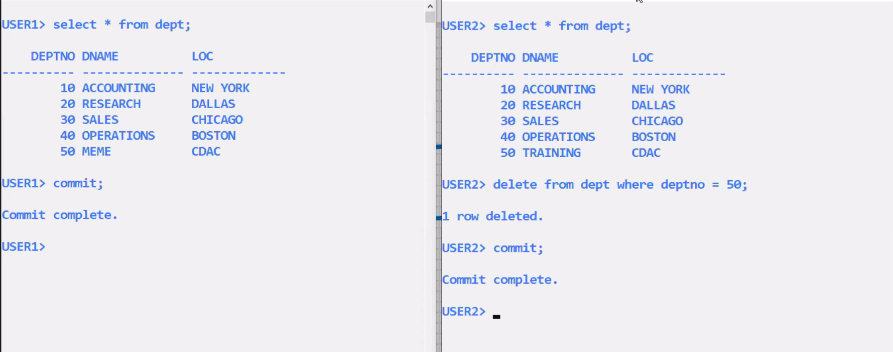

**Optimistic locking->automatic row locking mechanism in MySQL and Oracle.**

**Pessimistic locking->lock the rows Manually in advance before issuing update or delete**

* To lock the rows manually, then you have to use select statement with the **for update clause.**

**Select * from emp for update;**

* Locks are automatically released when you rollback and commit

**Lock the table**

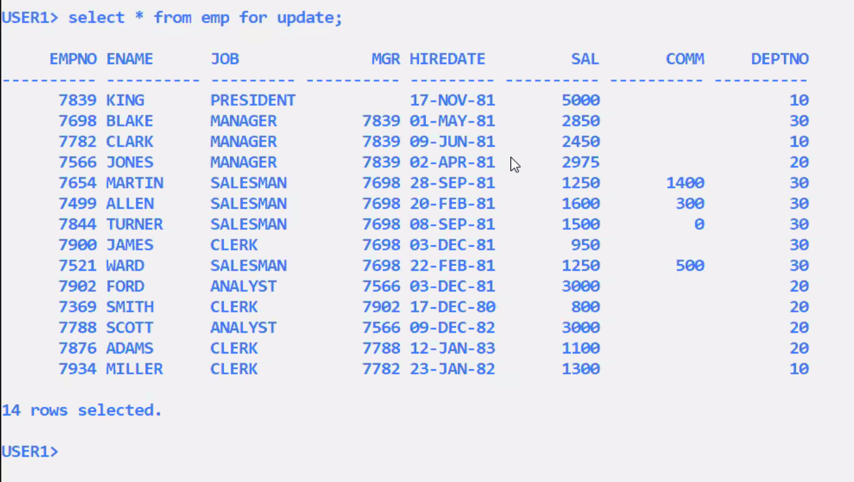

Select * from emp

Where deptno=10

For update; //by default it is wait

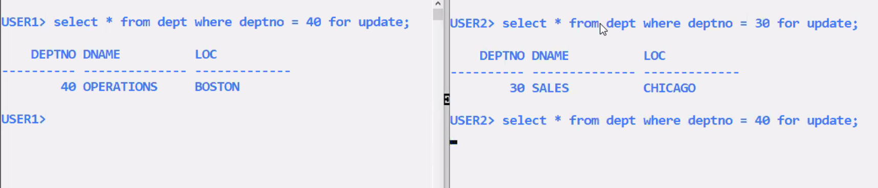

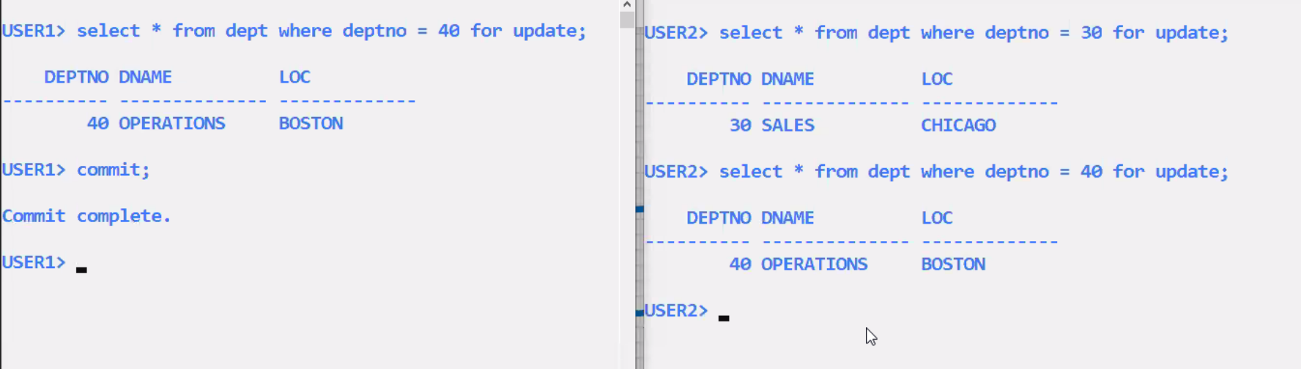

Select * from emp

Where deptno=10

For update wait;

Select * from emp

Where deptno=10

For update nowait;

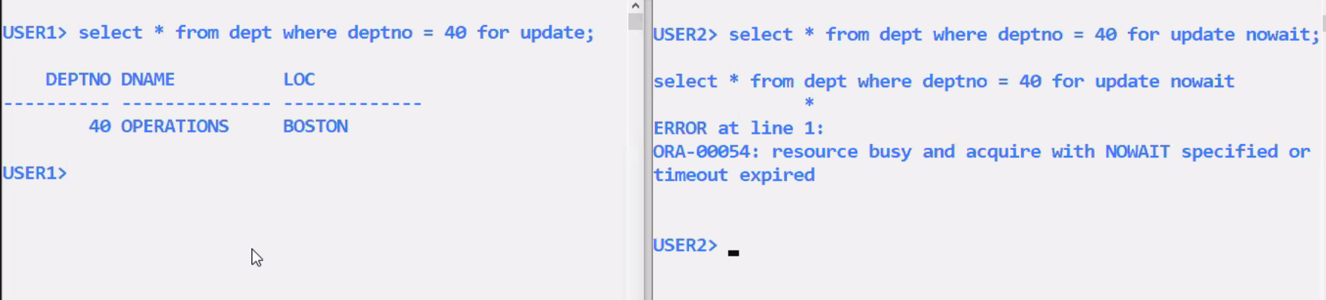

Select * from emp

Where deptno=10

For update wait 60; //waiting time(Seconds)

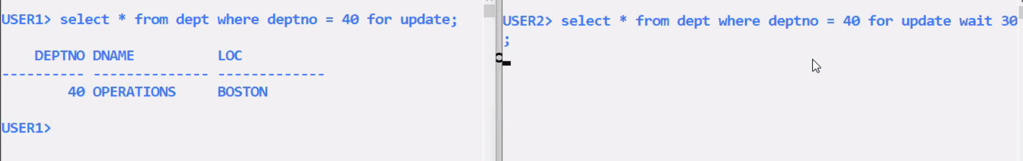

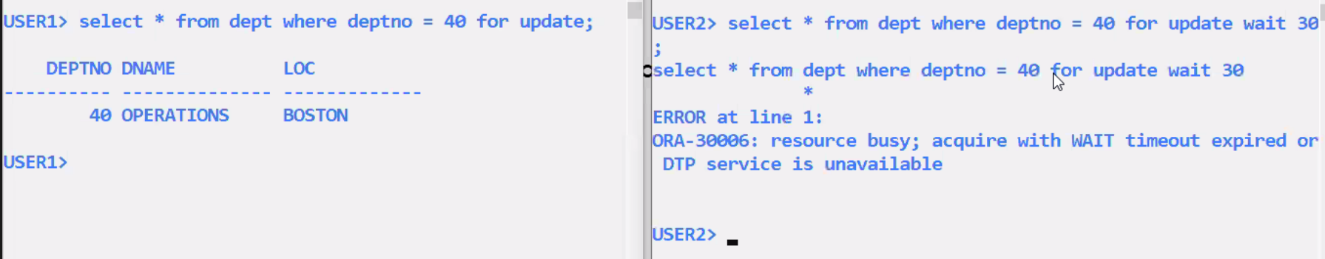

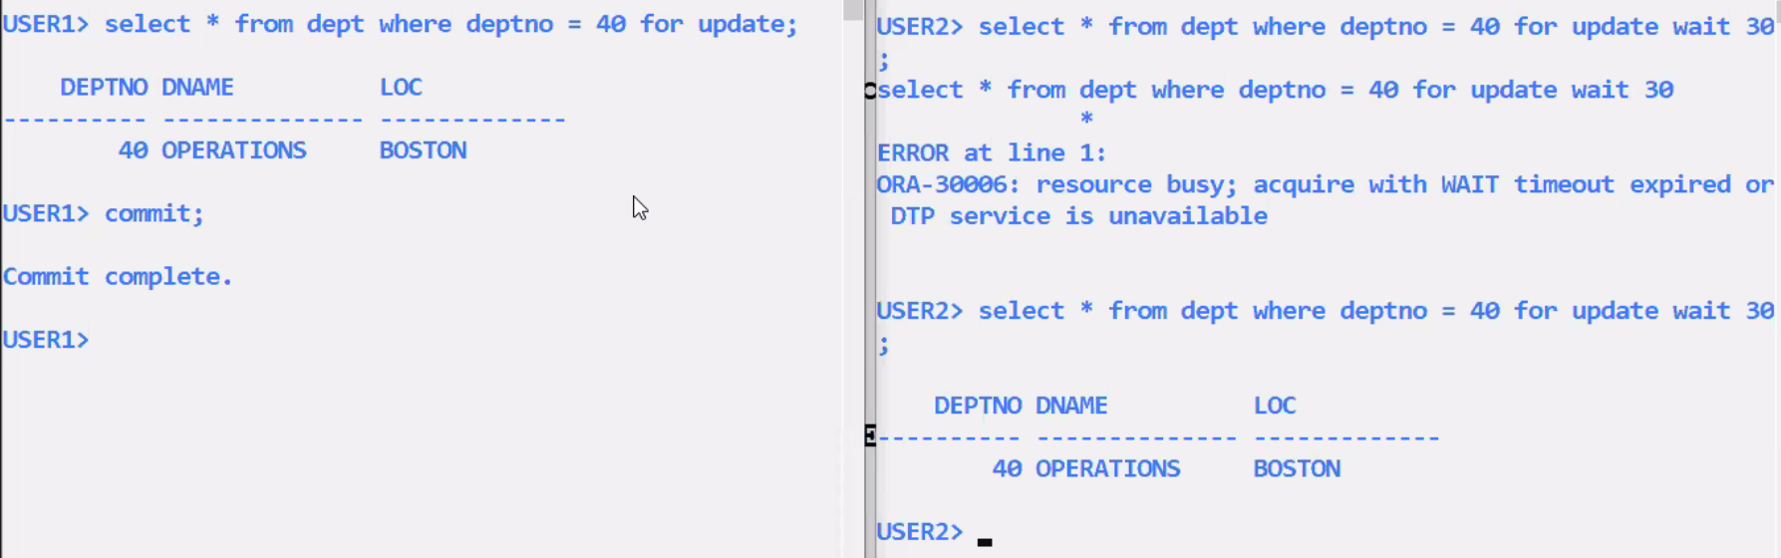

MySQL workbench to try out row locking:-

Click on query (menu at the top)->new tab to current server ->click on it

Now you have 2 Query windows to try out row locking

If you get stuck in the request queue, to abort the operation:-

Click on Query(menu at the top)->click on stop

* Wait/nowait options are not available in MySQL
* In MySQL it is default Wait.

**MySQL – SQL – Functions**

Character functions

* These are applicable for char datatypes and varchar datatypes.

EMP Table

|  |  |
| --- | --- |
| FNAME | LNAME |
| ARUN | PURUN |
| TARUN | ARUN |
| SIRAN | KIRAN |
| NUTAN | PURAN |

Create table emp(

fname varchar(20)

lname varchar(20)

);

Select fname, lname from emp;

**Concatenate function:**

Select concat (fname, lname) from emp;

concat (fname, lname)

------------------------------

ArunPurun

TarunArun

Sirunkirun

NutanPuran

Select concat (fname, ‘ ’,lname) from emp;

concat (fname,’ ’,lname)

------------------------------

Arun Purun

Tarun Arun

Sirun kirun

Nutan Puran

In Oracle:-

Select concat(concat(fname,’ ’),lname) from emp;

* **Max upto 255** levels for **function within function** (common for all RDBMS)
* This upper of SQL can be exceeded with the help of Views

Select concat(‘Mr. ’,fname,’ ’,lname) from emp;

**Upper function:**

Select concat(upper(fname), upper(lname)) from emp;

Select upper(concat(fname,lname)) from emp;

ARUNPURUN

TARUNARUN

SIRUNKIRUN

NUTANPURAN

Update emp set fname = upper(fname) ;

Solution for case insensitive query in Oracle

Select * from emp where upper(fname) = ‘ARUN’;

**Lower function:**

Select concat(lower(fname), lower (lname)) from emp;

Select lower (concat(fname,lname)) from emp;

arunpurun

tarunarun

sirunkirun

nutanpuran

Update emp set fname = lower (fname) ;

Solution for case insensitive query in Oracle

Select * from emp where lower (fname) = ‘ARUN’;

**Initcap function: (not available in MySQL, available in Oracle)**

Select initcap(fname) from emp;

Arun

Tarun

Sirun

Nutan

**Lpad function:(Stands for left pad) Right justified**

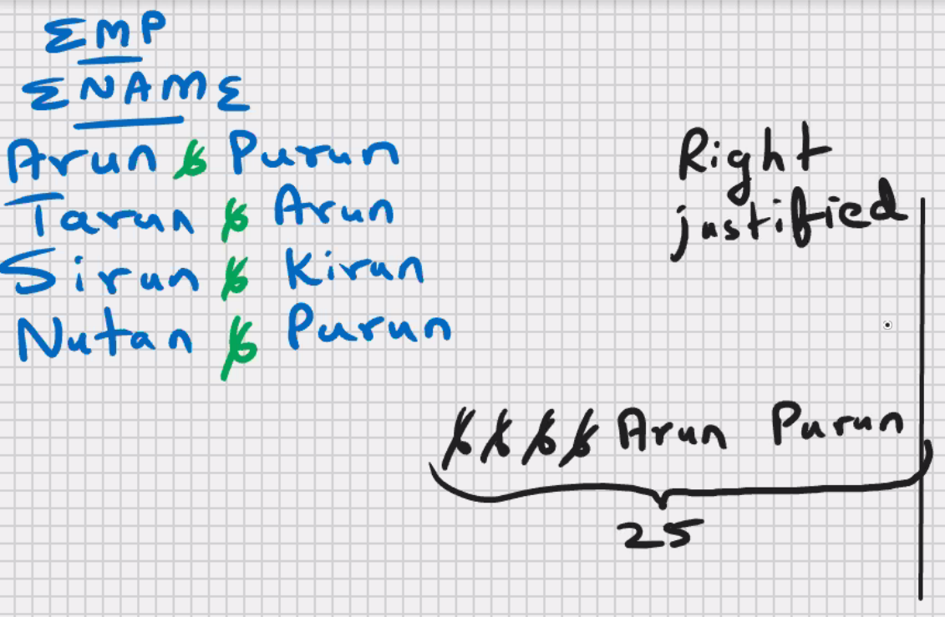EMP table

Ename

Arun Purun

Tarun Arun

Sirun kirun

Nutan Puran

Select lpad(ename,25,’ ’) from emp;

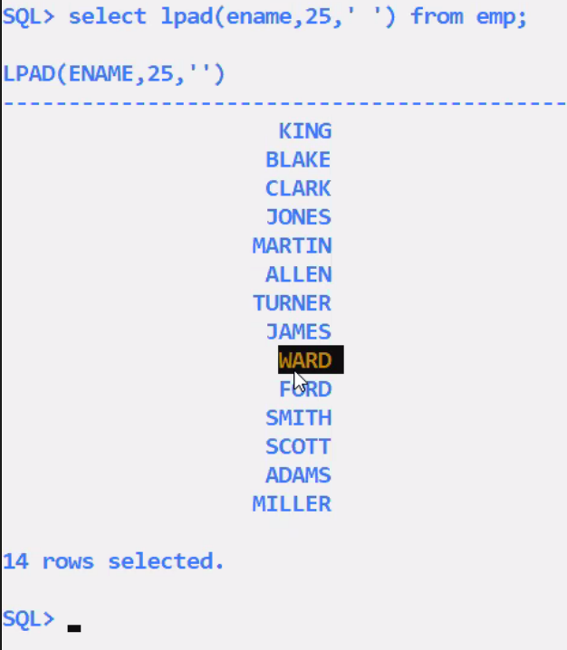

* Use for right justification

Select lpad(ename,25,’* ’) from emp;

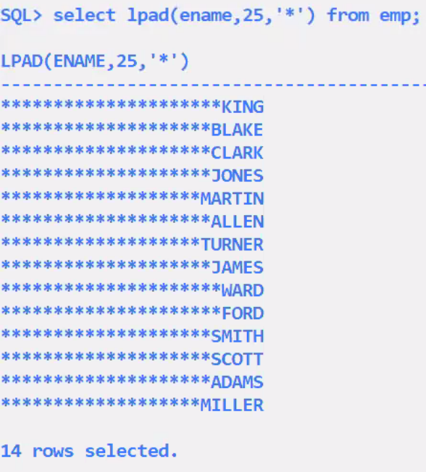

* Use for cheque printing

**Rpad function:(Stands for right pad) Left justified**

**Uses**

* Left justification of numeric data
* Convert varchar to char (convert variable length to fixed length)
* Cheque printing

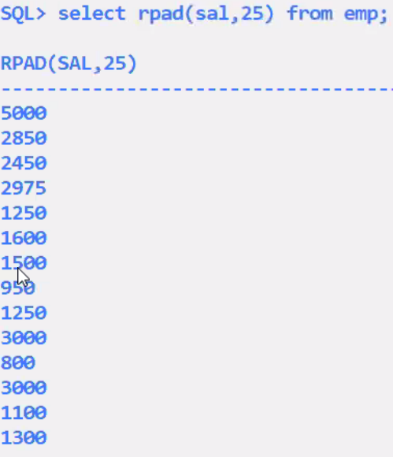

Homework : centre justified

**Ltrim function:**

Select ltrim(ename) from emp;

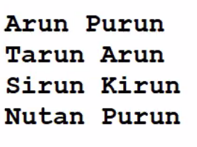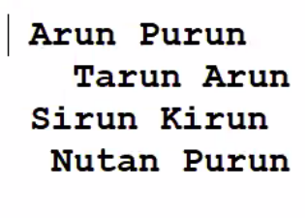

Uses

* Left justification

**Rtrim function:**

Select rtrim(ename) from emp;

* Remove the spaces from right side
* Right justification e.g. lpad(rtrim(ename)….)
* Convert char to varchar (convert fixed length to variable length)

**Trim function:**

Select trim(ename) from emp;

* Removes the blank spaces from both the sides

**Substr function:**

Select Substr(ename,3) from emp;

un Purun

run Arun

run kirun

tan Puran

* Used to extract a part of the string
* Substr(‘kharghar’,5)->’ghar’

Select Substr(ename,3,2) from emp;

2 -> number of characters

un

ru

ru

ta

Select Substr(ename,-3) from emp;

run

run

run

run

Select Substr(ename,-3,2) from emp;

ru

ru

ru

ru

substr(‘New Mumbai’,1,3) -> New

substr(‘New Mumbai’,5) -> Mumbai

**replace function:**

select replace(ename,’un’,’xy’) from emp;

un->xy

Arxy Purxy

Tarxy Arxy

Sirxy Kirxy

Nutan purxy

select replace(ename,’un’) from emp; ->works in oracle (not supported by MySQL)

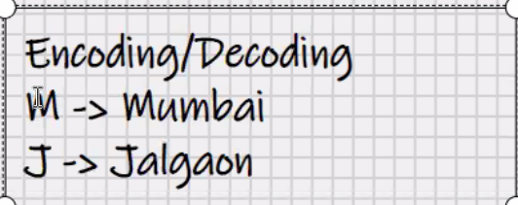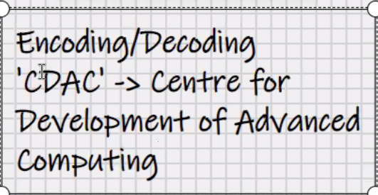

ar pur

tar ar

sir kir

nutan pur

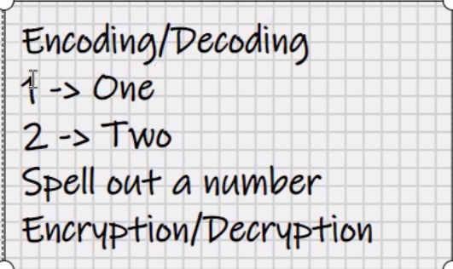

**Translate function:**

Translate (ename,’un’,’xy’) from emp;

U -> x

n -> y

arxy pxrxy

etc.

Translate (ename,’un’,’xyz’) from emp;

U -> x

n -> y

->z

* Translate function is supported by oracle (not supported by MySQL)

**Instr function:**

Select instr(ename,’un’) from emp;

Returns starting position of string

3

4

4

10

**If string is not found returns 0.**

**uses**

* Used to check if one string exists in another string

EMP table

Ename

Anirudha

Bhavesh

chaitanya

Dishi

**Length function:**

Select bhavesh (ename) from emp;

8

7

9

5

**Ascii function:**

Select ascii(ename) from emp;

65

66

67

68

Return ascii value of first character in string

Select ascii(substr(ename,2)) from emp;

Select ascii(‘z’) from emp;

122

122

122

122

Select distinct ascii(‘z’) from emp;

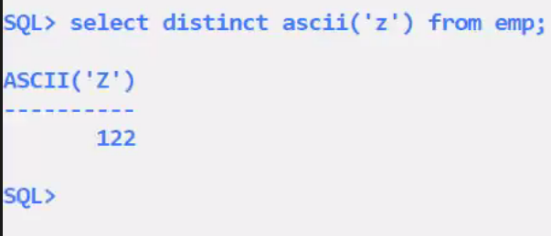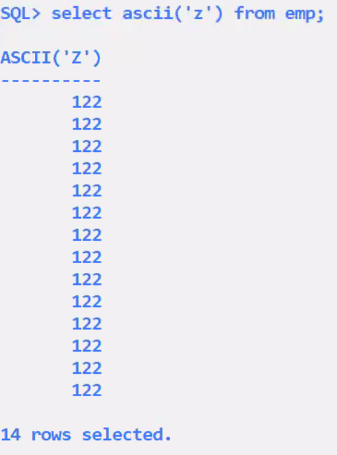

**Use mysql;**

**Select distinct ascii(‘z’) from user;**

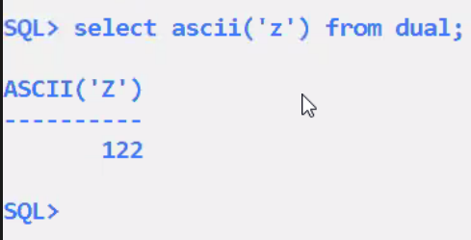

122

Select ascii(‘z’) from dual;

* Dual is a system table
* Dual is a dummy table
* It contains only 1 row and
* 1 column

Select substr(‘New Mumbai’,1,3) from dual;

Select 3*12 from dual;

Select ‘Welcome to CDAC Mumbai’ “MESSAGE” from dual;

Select char(65 using utf8) from dual;

A

* Where utf8 is the given character set for us English else default is binary character set

**Soundex function:**

Emp table

Ename

Arun

Bhavesh

Chaitanya

Select * from emp where soundex(ename)= soundex(‘Aruun’);

A , e, I, o ,u ,y remove the vowels from the string and compares

(work for simple names)

**Number functions:**

Emp table

Sal

1234.567

1848.019

1375.618

1752.156

In MySQL

Sal float

In Oracle

Sal number(7,3)

**Round function:**

Select round(sal) from emp;

1235

1848

1376

1752

Select round(sal,1) from emp;

1234.6

1848

Select round(sal,2) from emp;

1234.57

1848.02

Etc.

Select round(sal,-2) from emp;

1200

1800

1400

1800

Select round(sal,-3) from emp;

1000

2000

1000

2000

In MySQL

**Truncate function:**

Selelct truncate(sal,0) from emp;

Removes the decimal

1234

1848

1375

1752

Uses

* Date calculations and time calculations

Selelct truncate(sal,1) from emp;

1234.5

1848

1375.6

1752.1

Selelct truncate(sal,2) from emp;

1234.56

1848.01

1375.61

1752.15

Selelct truncate(sal,-2) from emp;

1200

1800

1300

1700

In oracle:-

Select trunc(sal) from emp;

Select trunc(sal,1) from emp;

Select trunc(sal,2) from emp;

Select trunc(sal,-2) from emp;

**Ceil function :**

Select ceil(sal) from emp;

If there is any value at all in the decimal then it will add 1 to the whole number

1235

1849

1376

1753

Uses

* Bill payments
* Interest calculation
* EMI payments
* Etc

**Floor function:**

Select floor (sal) from emp;

1234

1848

1375

1753

Select truncate(3.6,0), floor(3.6), truncate(-3.6,0), floor(-3.6) from dual; 3 3 -3 -4

**Sign function:**

Select sign(-15) from dual;

-1

If number is negative returns -1

If number is positive returns 1

If number is zero returns 0

Uses:

* Check if number is +ve or -ve
* Temperature
* Sensex
* Voltage
* Blood group
* Medical report
* Bank balance
* Profit and loss
* Distance

X and Y two unknown numbers

X=10

Y=20

Sign(x-y)

**To find greater of two number use sign function**

Lateral Thinking by Ayn Rand

**Mod function:**

Select mod(9,5) from dual;

4

Select mod(8.22,2.2) from dual;

1.62

**Sqrt function:**

Select sqrt(81) from dual;

9

Only works for positive number

**Power function:**

Select power(10,3) from dual;

1000

Select power(1000,1/3) from dual;

10

**Abs function: (absolute number)**

Select abs(-10)from dual;

Return positive value

10

**Some more functions**

Sin(x)

Cos(x)

Tan(x)

X is in radians

Ln(y)

Log(n,m) ->logn(m)